EXERCISE 17
- Find and list the ids and spouse names of all employees who are married.
SELECT e_id, s_name FROM employee_per WHERE m_status = 'Y';
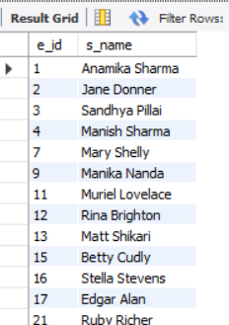
- Change the above so that the display is sorted on spouse names.
SELECT e_id, s_name FROM employee_per WHERE m_status = 'Y' ORDER BY s_name;
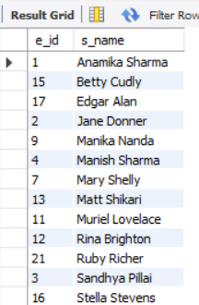
- How many employees do we have under each sex (male and female)?
SELECT sex, COUNT(*) AS total FROM employee_per GROUP BY sex;
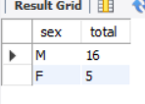
- How many of our employees are married and unmarried?
SELECT m_status, COUNT(*) AS total FROM employee_per GROUP BY m_status;
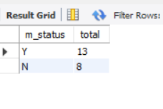

- Find the total number of children.
SELECT SUM(children) AS total_children FROM employee_per;
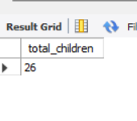
- Make unique groups of children and find the number of each group. Sort the display with the group having maximum children, at the top.
SELECT children, COUNT(*) AS num_employees FROM employee_per GROUP BY children ORDER BY num_employees DESC;
